Skinning your fox for the taxidermist using the dorsal incision.
This is the most commonly used cut I utilise in mounting foxes. Case skinning, (hock to hock), is also used, just not as often.
- 1/ Tools used in skinning this fox include a scalpel, disposable blades, a small ear turning tool, side cutters, tail stripper and a tail cutting guide.
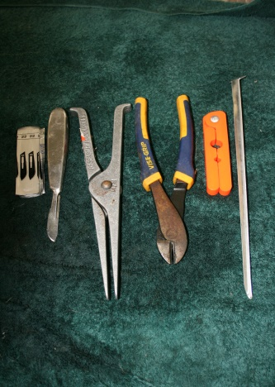
- 2/ Make an incision, blade facing up from the back of ears to just past the base of the tail along the spine.
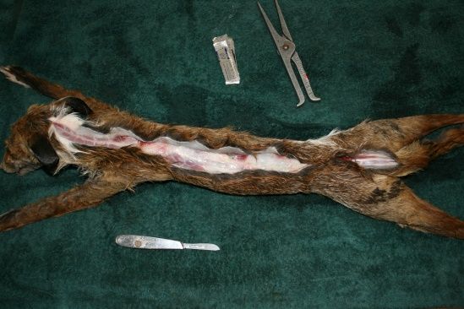
- 3/ Work the skin down the sides of the neck, ribcage, rump and tail base.
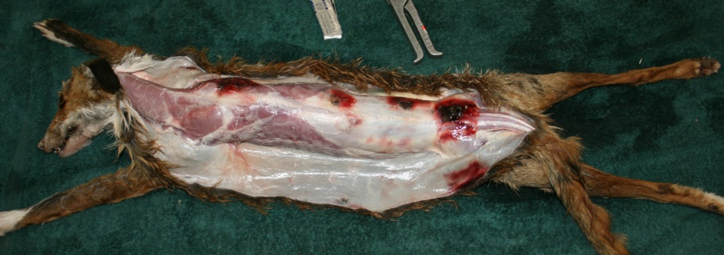
- 4/ Snip the tail bone where it meets the rump.
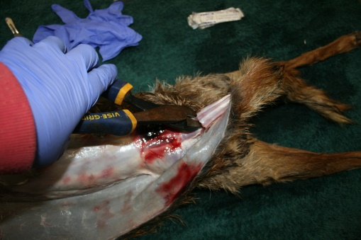

- 5/ Keep working the skin around the abdomen.
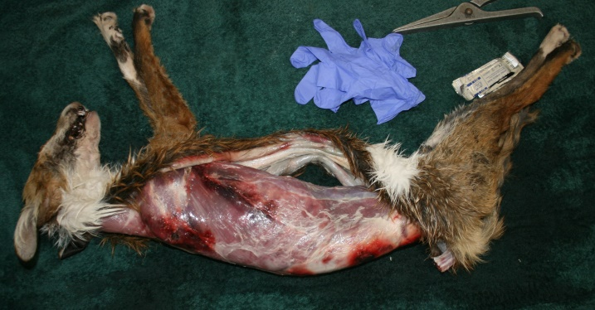
- 6/ Push the rear legs up and out of the skin and tube/pull the skin down the leg past the hock.
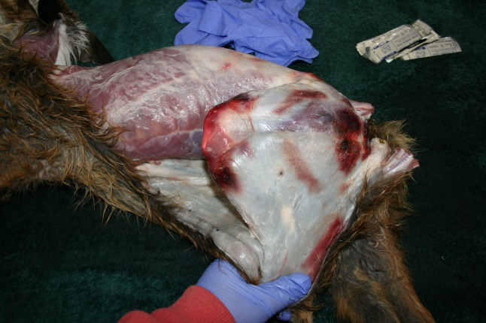
- 7/ Pull the skin down to the toes, carefully using your scalpel as necessary and cut the toe bones with the side cutters as shown.
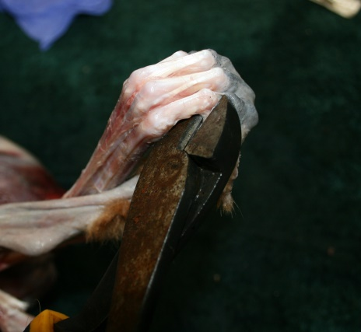
- 8/ If you cannot for any reason tube down to the toes, a relief cut can be made from the foot pad to the hock on the inside of the leg as shown. Avoid cutting the foot pad if you are having a running mount or where the pad may be visible, otherwise cut through it.
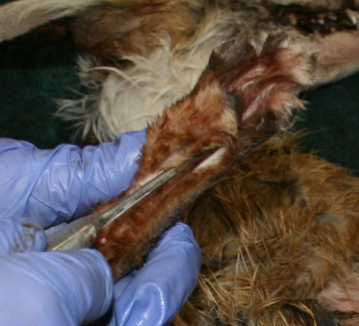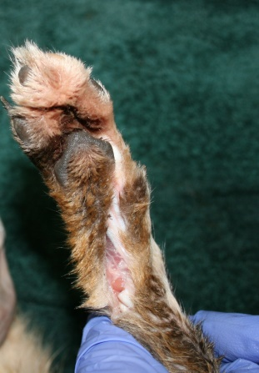

- 9/ As you approach the ears you will notice the cream bowl of the ear base.
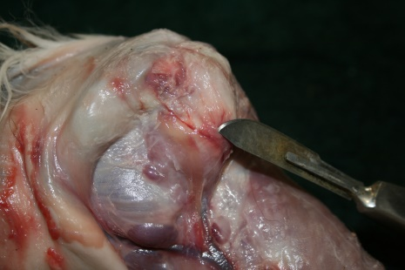
- 10/ Cut the ear off as close to the skull as possible. You will see the ear canal tube.
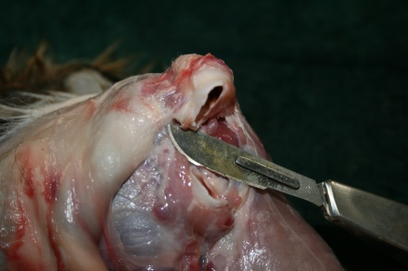
- 11/ Once the ears are free, peel the skin down the face until you see the white of the eye socket.
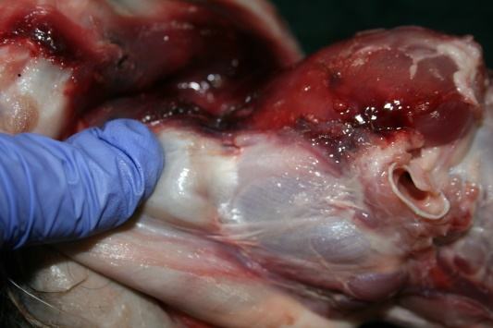
- 12/ Insert your left finger and pull the skin tight as you carefully cut the skin away from the eye socket, keeping your blade on the bone.
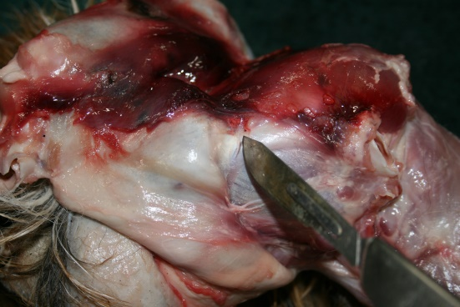
- 13/ When you get to the jaw, make a cut as shown and cut along the gum line as close to the teeth as possible.
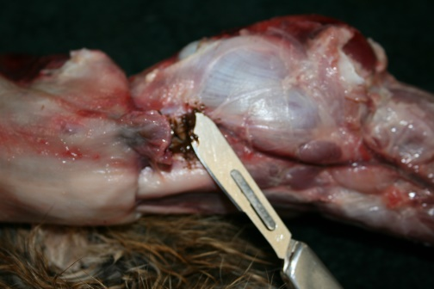
- 14/ Cut the nose off at the cartilage and the head skin will be free.
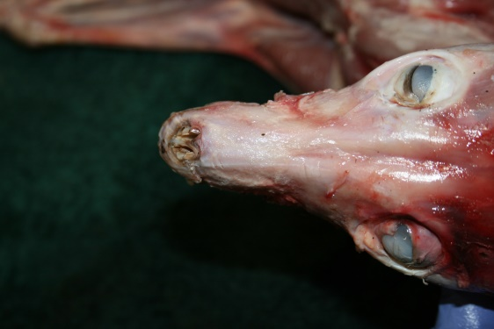
- 15/ Take a tail stripper and clamp it on the tail base and holding the base in a vise or similar, pull firmly down the tail, releasing the tail bone.
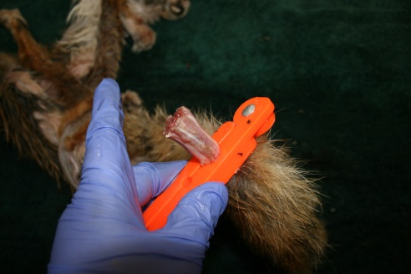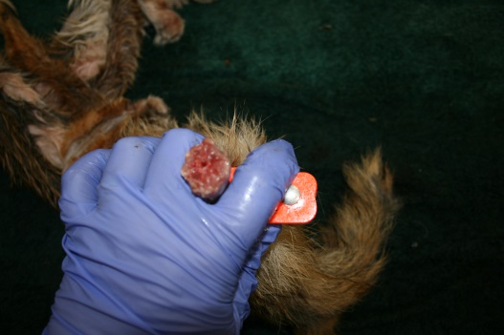
- 16/ Using the tail guide cut the tail open to the tip, blade facing up. This enables thorough salting and fleshing of the tail.
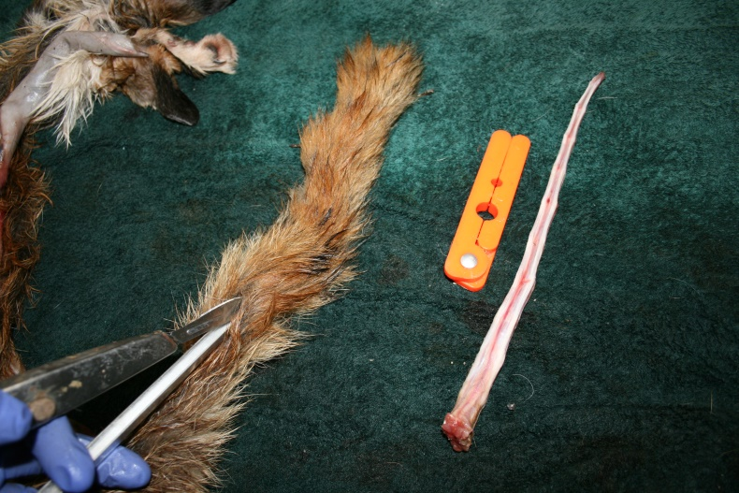

- 17 Insert the ear pliers into the ear between the flesh and cartilage and carefully ‘open’ or separate the ear skin from the cartilage all the way to the edges. This enables the ears to be salted.
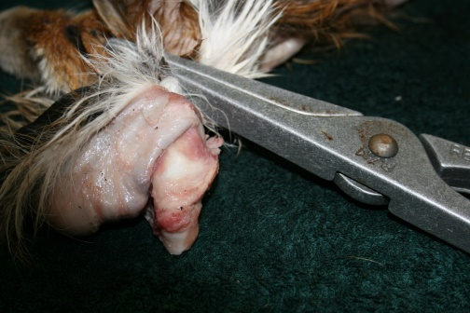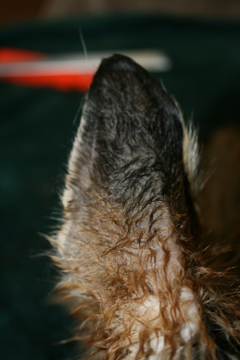
- 18/ Take your scalpel and split the eyelid and lip skin to enable salting.
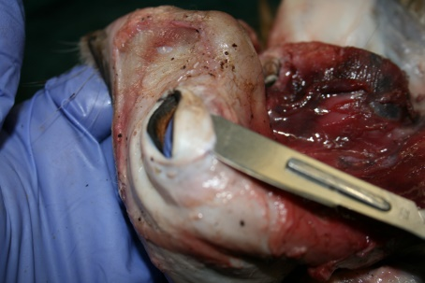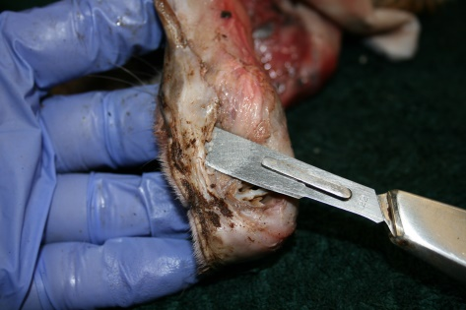
- 19/ The lip skin opened up ready for salting.
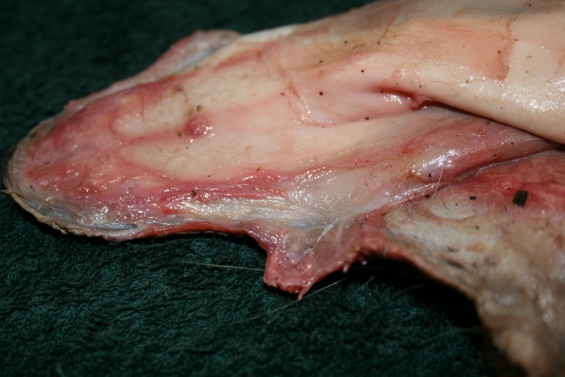
- 20/ This is the salt I use and buy from PDF foods. Around $12 for 25kg. Iodised salt is OK and won’t interfere with tanning at all.
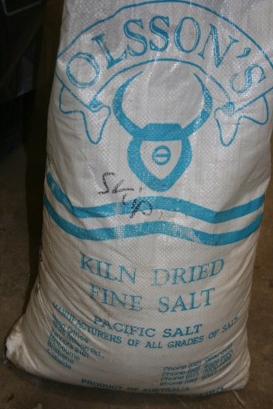
21/ Thoroughly salt the entire skin ONLY if all of the above has been done.
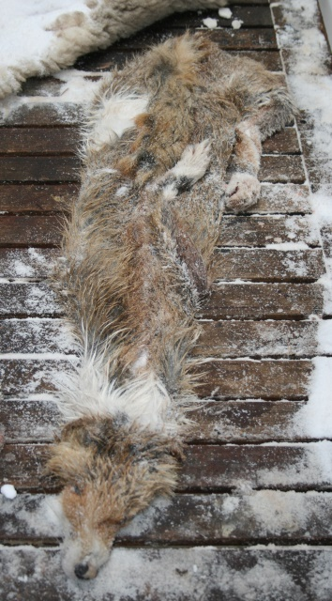

Removing abdomen only & freezing
The following pictures and procedure are for those people who, for whatever reason, cannot perform all the above, but don’t have room to freeze a whole fox in a freezer. The skin folds up to quite a small parcel, and can be placed into a freezer with no one else noticing. Don’t forget to label it!
- After removing the skin from the abdomen and legs to the hocks and cutting the tail at the base. You can cut the leg bones as shown in the pictures below, leaving the small section of bone in place.
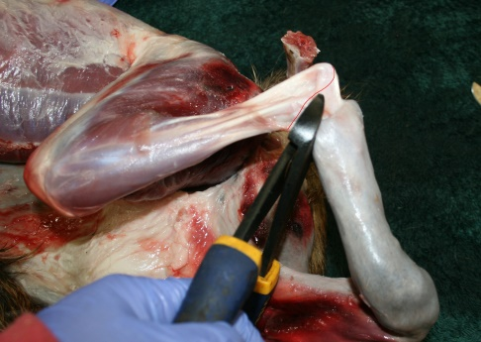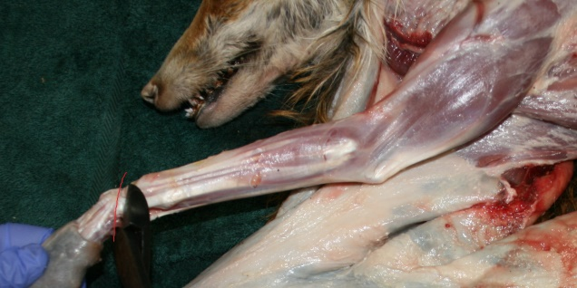
- Showing, in red, where to cut the carcass to leave the head, feet & tail in for the taxidermist to finish caping at a later stage. This must be either frozen or delivered to a taxidermist ASAP.
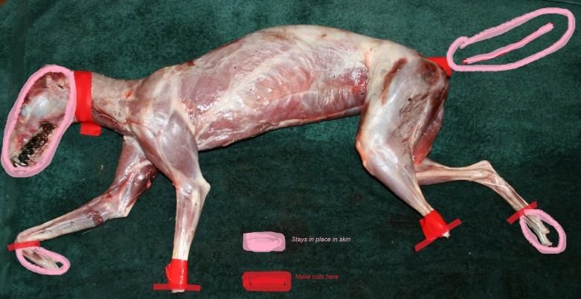
- A simple box used to mail/courier frozen skins with the head and feet still in. The foam box is lined with foil, newspaper and once the skin is in place, more scrunched up newspaper is packed tightly around it to keep it cold and soak up any fluid.
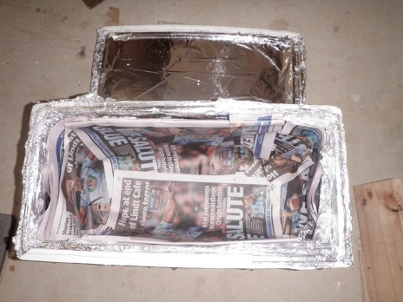
I hope this guide helps you skinning your fox for the taxidermist.

